

**EVEREST ENGINEERING COLLEGE**

**(AFFILIATED TO POKHARA UNIVERSITY)**

**Facial Emotion Detection Using OpenCV**

**Submitted By:**

Dibas Timilsena [21075410]

Sangita Bhattarai [21075433]

**Submitted To:**

Everest Engineering College

Department of Computer Engineering

Pokhara University, Nepal

**Sanepa-2, Lalitpur**

May 03, 2025

# **ABSTRACT**

Facial Emotion Detection Using OpenCV is a system that uses Artificial Intelligence (AI) and Computer Vision to understand how people feel just by looking at their facial expressions. This system takes images of faces, finds key features like eyes, eyebrows, and mouth, and uses machine learning to recognize emotions such as happy, sad, angry, surprised, fearful, disgusted, or neutral. By observing changes in facial movements, the system can detect emotions with good accuracy.

**Keywords:** *Facial Emotion Detection, human emotions, AI, machine learning, OpenCV*

**Table of Contents**

# 

# **LIST OF FIGURES**

Figure 3. 1 Work Flow Diagram 6

# **LIST OF TABLES**

# **Chapter 1: INTRODUCTION**

## Introduction

Facial Emotion Detection is a technology that uses AI to recognize emotions by analyzing facial expressions. It has applications in areas like healthcare, education, and security. By using Machine Learning (ML) and Deep Learning (DL), particularly Convolutional Neural Networks (CNNs), the system can learn from facial images to predict emotions like happiness, sadness, or anger. This project utilizes OpenCV and CNNs to detect emotions accurately and efficiently. It is useful for improving human-computer interaction and assisting in areas like mental health diagnosis.

## Background

Facial emotion detection is an important application of artificial intelligence (AI) and Computer vision, aimed at identifying human emotions based on facial expressions. Machine Learning (ML), a branch of AI, plays a vital role in this system. ML focuses on creating model that can learn from data and improve automatically without being manually programmed. It helps computer recognize patterns and make predictions based on input data, and is widely used in healthcare, finance, image recognition, speech processing, and many other fields. In facial emotion detection, ML techniques enable systems to learn from a large dataset of facial expression and predict emotions like happiness, sadness, anger, surprise, fear, and more from new images.

Deep Learning (DL) is a specialized area of ML that uses complex models with multiple layers to process data more efficiently and accurately. Deep Learning is particularly powerful for tasks like emotion detection because it can recognize subtle patterns in images, similar to how the human brain works. Within DL, Neural Networks are structures made of layers and nodes, designed to mimic the behavior of neurons in the human brain. They take input data, learn from it, and make predictions even when data varies. For facial emotion detection, neural networks learn important features from facial images to accurately classify emotions.

A more advanced version of neural networks is the Deep Neural Network (DNN), which contains multiple hidden layers. These hidden layers allow the system to learn deeper and more complex features from the input data, resulting in better performance. However, they require more training data and computation time. In the context of image processing tasks like facial emotion recognition, Convolutional Neural Networks (CNNs) are especially effective. CNNs are designed to automatically and adaptively learn spatial hierarchies of features from images. They consist mainly of three types of layers: the Convolutional Layer, Pooling Layer, and Fully Connected (FC) Layer.

The Convolutional Layer applies filters to the input images to extract important features such as edges, textures, and shapes, creating a feature map. The Pooling Layer then reduces the size of the feature map while preserving important information, making the model faster and less prone to overfitting. Different pooling methods include Max Pooling, Average Pooling, Min Pooling, and Sum Pooling. Finally, the Fully Connected Layer flattens the data and connects all neurons, allowing the system to make the final prediction and classify the input image into one of the predefined emotion categories. Overall, using Machine Learning, Deep Learning, and CNNs together provides a powerful framework for building accurate and reliable facial emotion detection systems using tools like OpenCV.

## Statement of Problem

The increase in human-computer interaction, it has become important for systems to understand human emotions better. However, recognizing emotions through facial expressions is still challenging because of different problems like changes in lighting, face angles, expressions, and even individual differences in how people show emotions. Many existing systems are not accurate enough or fail in real-time environments. Because of these issues, there is a need for a reliable and efficient facial emotion detection system that can work properly in different conditions. This project will focuses on solving these challenges by using OpenCV and Convolutional Neural Networks (CNNs) to improve emotion recognition accuracy and support areas like healthcare, education, and security.

## Objectives

* To build a facial emotion detection system using OpenCV and CNN with effective training, preprocessing, and performance tuning

## Scopes

The project aims to develop a deep learning-based system for detecting human emotions from facial expressions using OpenCV and CNN. It will focuses on training and validating a model to recognize emotions like happiness, sadness, anger, fear, and surprise from facial images. This system could support applications in fields like mental health monitoring, education, customer service, and security.

## Applications

* Educational Engagement Analysis

Teachers and educational apps can analyze student emotions during online learning to better understand engagement and adjust teaching methods.

* Mental Health Monitoring Healthcare professionals can use facial emotion detection to monitor patients’ emotional well-being and detect early signs of stress, depression, or anxiety.
* Security and Surveillance Systems Security agencies can implement emotion detection to identify suspicious behavior or emotional distress in public areas for preventive actions
* Further research and academic use

This research can be serve as reference for future researchers. It can be baseline for other learning models.

**Chapter 3: METHODOLOGY**

## Work Flow Diagram

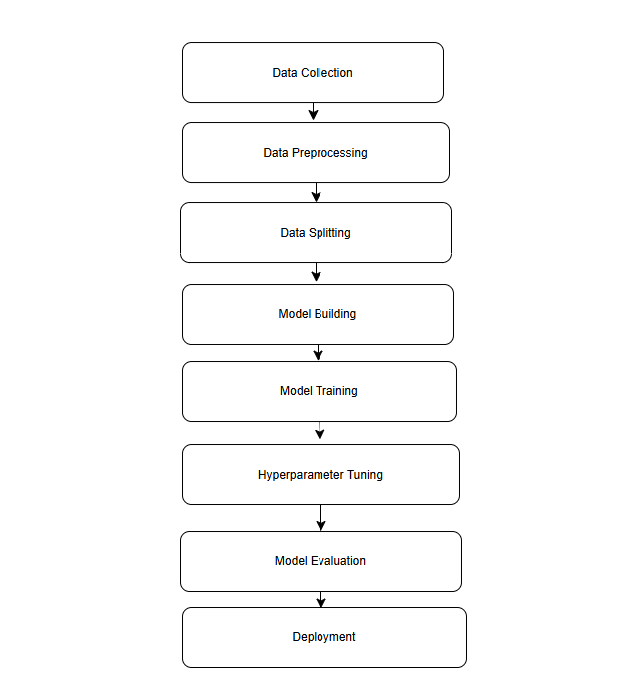

Figure 3. 1 Work Flow Diagram

## Work Flow

### 3.2.1 Data Collection

The FER2013 dataset [1], sourced from Kaggle, comprises thousands of labeled grayscale images depicting various facial emotions. These images are categorized into distinct emotional classes, including happiness, sadness, anger, fear, surprise, disgust, and neutrality[2].

**3.2.2 Data Preprocessing**

To improve the quality and variety of the dataset, we will apply several steps. First, we will resize all images to the same size and adjust the brightness and contrast to ensure consistent pixel values. We will then use OpenCV to detect and focus on the faces in the images. After that, we will convert the images to grayscale to simplify the data. Additionally, we will use techniques like rotating and flipping the images to create more examples, which will help the model learn better.

**3.2.3 Data Splitting**

We will create and train a Convolutional Neural Network (CNN) using the prepared training data. The CNN will be designed to learn important features and patterns in the faces that relate to different emotions. During training, the model will go through multiple cycles (epochs) to improve its accuracy in recognizing emotions.

### 3.2.4 Model Training

We will create and train a Convolutional Neural Network (CNN) using the prepared training data. The CNN will be designed to learn important features and patterns in the faces that relate to different emotions. During training, the model will go through multiple cycles (epochs) to improve its accuracy in recognizing emotions.

**3.2.5 Model Evaluation**

After training, we will assess how well the model works using various metrics, including accuracy, precision, recall, and F1-score on both the validation and testing sets. These metrics will help us understand how effective the model is at identifying emotions and how reliable it is.

**3.2.6 Hyperparameter Tuning**

To enhance the model's performance, we will adjust its settings (hyperparameters) using methods like Bayesian Optimization. This process will involve changing parameters such as the learning rate, the number of layers, and the batch size to improve the model's accuracy and reduce the risk of overfitting.

**3.2.7 Final Deployment**

Once the model performs satisfactorily, we will deploy it for real-time facial emotion detection. Using OpenCV, the model will analyze live video feeds or uploaded images, accurately detecting faces and predicting the corresponding emotions in real-time applications.